Spring Clean your Plate
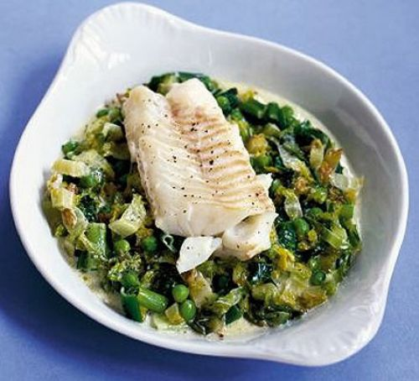
Dinner (Around 450kcals each)
- Prawn noodle stir fry
Fry onion garlic and ginger to taste in 1 tsp rapeseed oil for 1 minute, add 100g pack of raw prawns (defrosted if frozen) and cook until they turn pink. Add ½ pack stir veggies and cook until warmed through, add a splash of reduced salt soy sauce and 1 individual pack ready-to-heat noodles, stir fry until piping hot.

- Vegetable kebab wraps with tzatziki (V)
Chop ½ a courgette, ½ red & Green pepper into bite sized pieces Thread onto skewers with 6 cherry tomatoes and 6 button mushrooms, spray with a little oil and grill until cooked through. Serve in 2 wraps with 2 handfuls rocket and 4tbso fat free Greek yoghurt mixed with grated cucumber (squeeze to remove excess water) garlic lemon juice, zest and black pepper.

- Roast beef and Yorkshire pudding
2 slices lean roast beef with 2 medium roast potatoes, 1 small Yorkshire pudding, steamed cauliflower and green beans, with 1tbsp horseradish and reduced salt gravy

- Grilled chicken with Mediterranean couscous (V)
Cut ½ a courgette, ½ red pepper, ½ aubergine and ½ red onion into pieces add to a roasting tray, with 1 skinless chicken fillet, sprinkle with fresh or dries herbs of your choice, roast in a medium oven until everything is cooked through, serve with 7tbsp prepared couscous dressed with lemon juice and zest fresh coriander and parsley.

- Garlic Mushroom and Broccoli Pasta. (V)
Fry ½ a chopped onion in 1tsp olive oil in a non stick frying pan, add garlic to taste and cook for 1 minute, add 2 handfuls button mushrooms and cook until brown,
Mix into 8tbsp cooked wholewheat pasta and cooked broccoli mix in 3 tbsp low fat herby cheese

- Baked lamb & Sweetpotato wedges.
Cut 1 sweet potato into wedges brush with a little olive oil and oven bake in a roasting tin with 1 lean lamb steak, serve with salad.

- Simple Salmon Supper
Serve 1 grilled salmon fillet with 4 new potatoes tossed in 1tsp low fat spread, with steamed veggies of choice.

- Quorn Bolognese (V)
Fry 1 small chopped onion, 1 sliced carrot, and garlic to taste in 2tsp olive oil, until soft, add 100g quorn mince and cook through, add 1 handful sliced mushrooms and cook until soft, add ½ can chopped tomatoes, 1tbsp tomato puree, mixed dried herbs and 1 veggie stock cube, simmer until thickened, serve with 150g wholewheat spaghetti and salad,

- Stuffed peppers (V)
Mix together 5 tbsp cooked brown rice. ½ diced small red onion, 1 chopped tomato, 3 tbsp sweetcorn, 5 chopped olives, 50g crumbled reduced fat feta, cut 1 large red pepper in half lengthways slicing through the stalk, remove seeds and pith and stuff both halves of pepper with the mixture, cover with piled foil and baked until cooked through, serve with salad.

- Fish with peas & lettuce

Mix together 1 little gem lettuce shredded with, 2 thickly sliced spring onions and a handful of frozen peas in a microwave-proof dish. Drizzle with 1tsp olive oil. Sit a white fish fillet on top, spoon over 1tbsp reduced fat crème fraîche, then season. Cover with cling film, Pierce film.Microwave on Medium for 6-8 mins until the fish is cooked. Lift fish off the lettuce and give lettuce and peas a good stir. Spoon lettuce mix and sauce onto a plate, then sit fish on top.

